**Refill on Soup**

***Crypto***

**Challenge:**

How could we have missed this?? There were TWO word searches stuck together that the DEADFACE courier dropped. We’ve already solved the first one, but maybe solving this second word search will help us uncover the secret message they’re trying to covertly relay to the other members of DEADFACE. Hopefully, THIS will tell us how they plan to execute their next move.

Submit the flag as flag{TARGETNAME} (e.g., flag{THISISTHEANSWER})

Attached - Deadface_Word_Search_Part_2.png

**Approach:**

Quite the same as the Letter Soup challenge, the png image is a word search which we solve according to the words given:

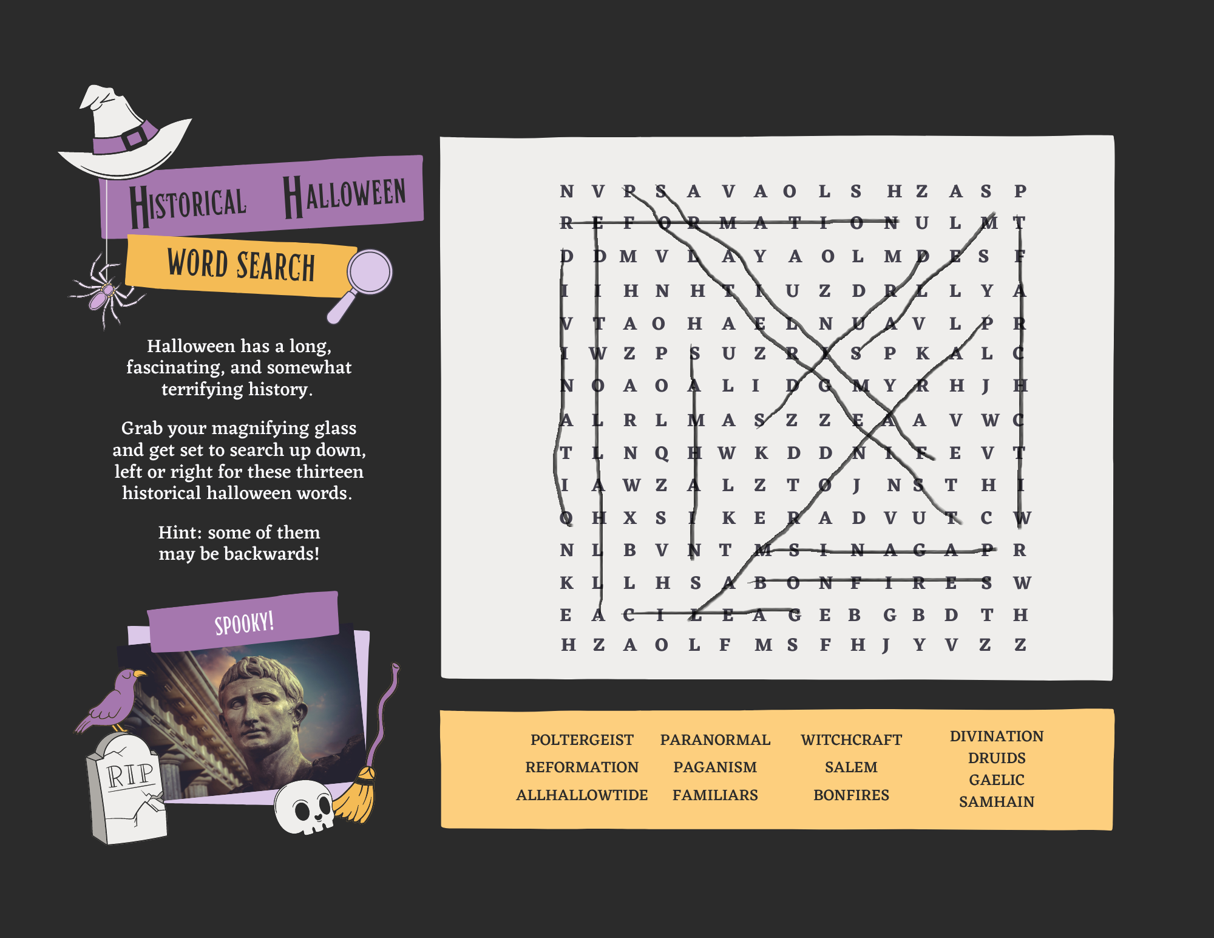

And we are left with the following letters combines into a string:

NVAVAOLSHZASPULMVYAOLMSHNHUZDLYAOHANVLZPUZPKLAOLIYHJRLAZZAVWNQWKDDEVWZLZTJNTHXSKEADVUCNBVTRKLHSWEEBGBDTHHZAOLFMSFHJYVZZ

Upon caesar cipher decode on right shift 7 we get:

GOTOTHELASTLINEFORTHEFLAGANSWERTHATGOESINSIDETHEBRACKETSSTOPGJPDWWXOPSESMCGMAQLDXTWONVGUOMKDEALPXXUZUWMAASTHEYFLYACROSS

Well the text in between doesn’t make much of a sense, but we got our flag at the end, hence:

**Flag: flag{ASTHEYFLYACROSS}**

Congrats!!

Happy Hacking!